EXPERIMENT 3

CSA 1438 ETHICAL HACKING FOR MESSAGING SYSTEM

LAB SESSION

Part 1

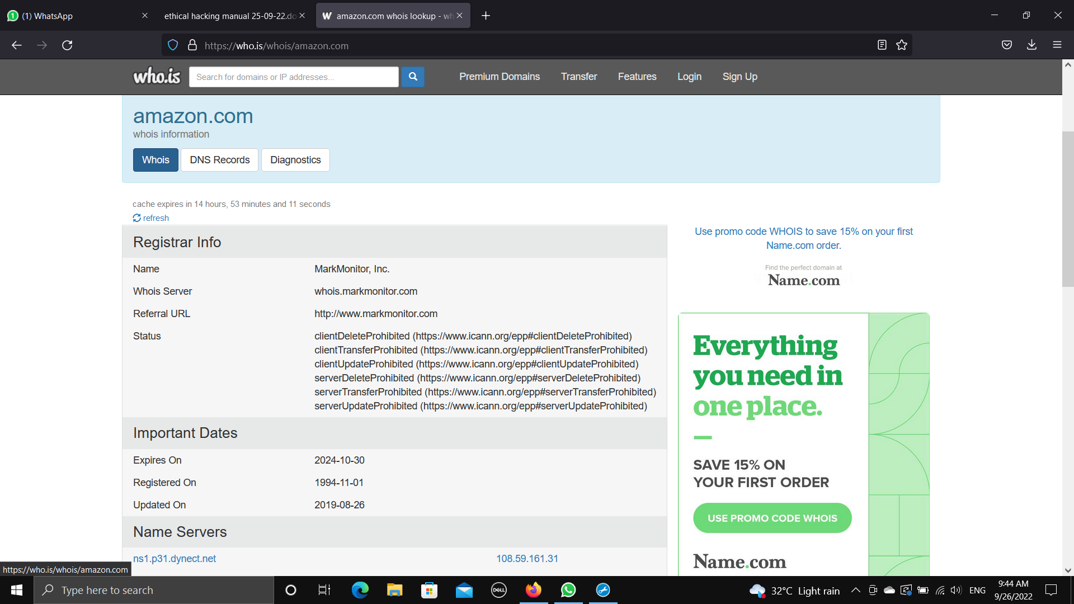

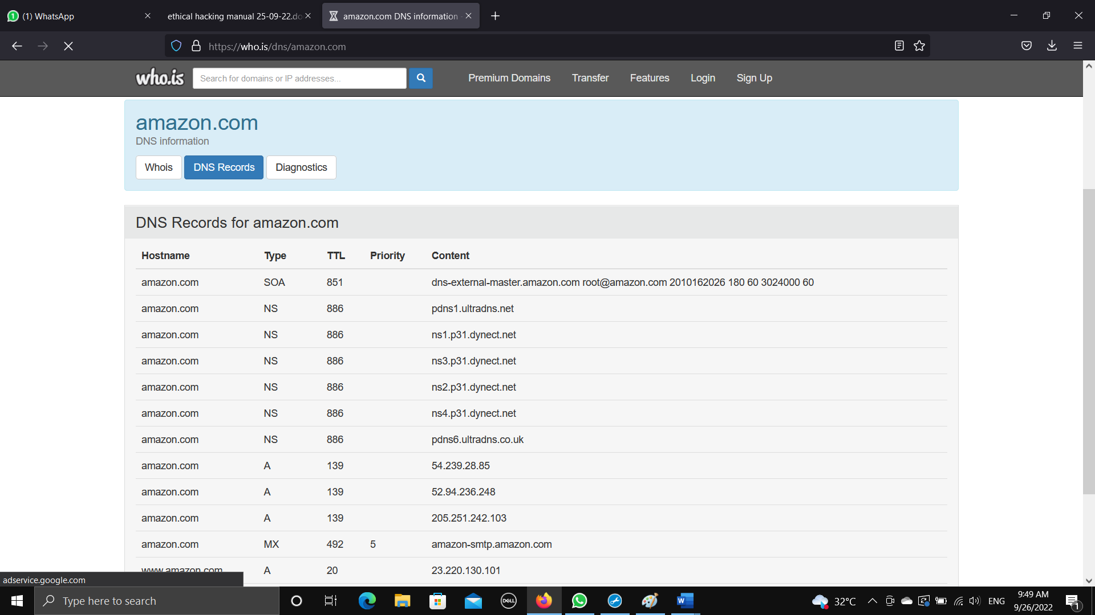

Part 3

